Set up a home lab-AD lab in Azure

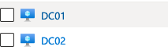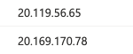

Lab lay out------ VNet -> DC01/DC02 -> Active Directory -> client ready

Reason to have two Domain controllers is to prevent one DC is offline and the other is still working

1. Go to MS Azure and direct to Resource groups, create the AD-LAB project

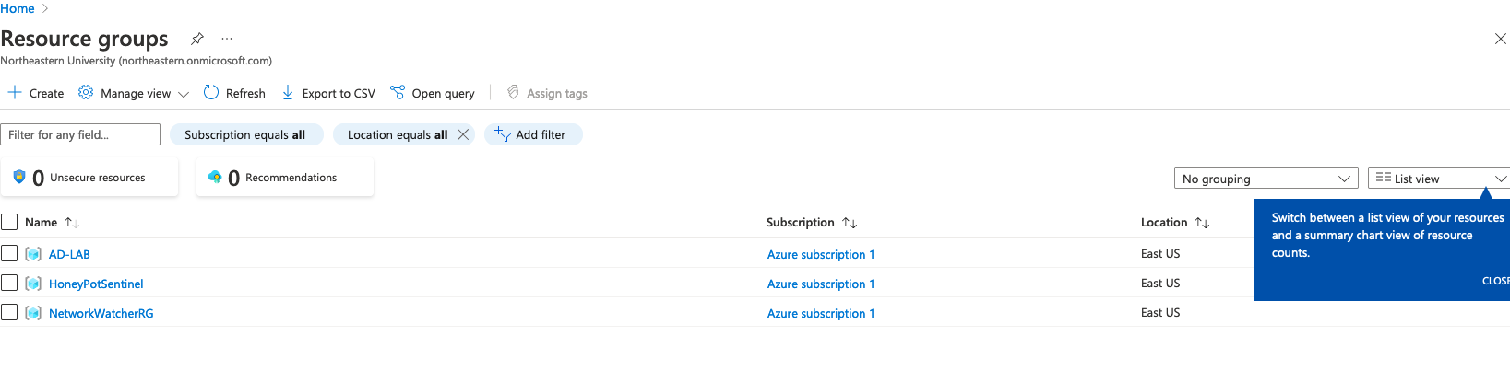

1. Go to virtual networks and create a new networks
   1. Go to IP address and set up default subnet

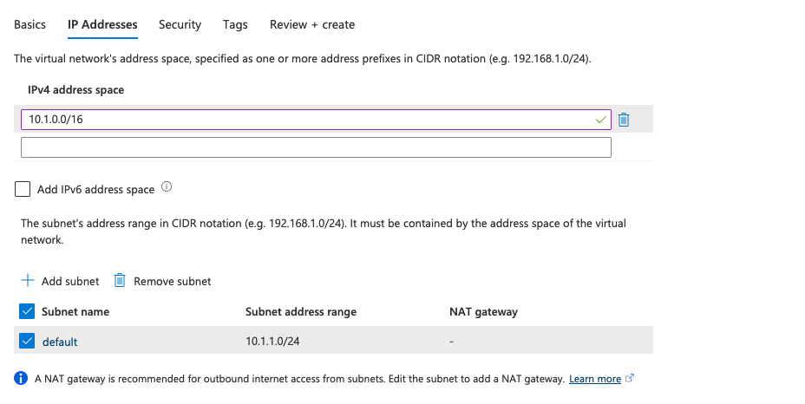

* 1. Next direct to Security, set everything disabled.
  2. Create the networks

1. Go to Virtual machines and create a new virtual machine,
   1. Select Availability set in Availability options
      1. Create new and give it a name and leave it as default

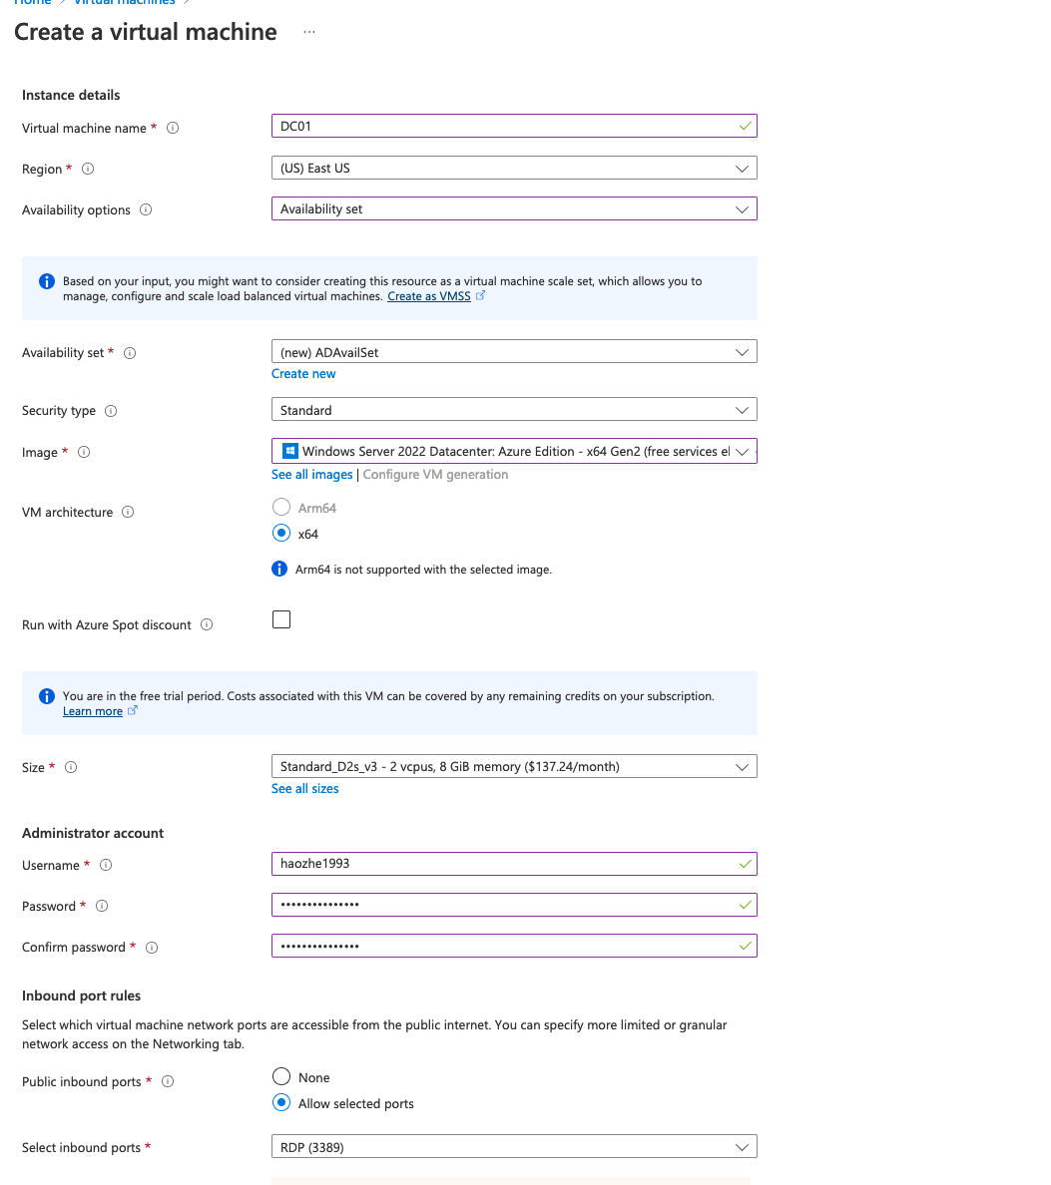

* 1. Go to disks and change to Standard HHD and create a new disk, use 10GiB is enough
  2. Go to Networking, not changing IP for this particular project(No need to lock down rdp)
  3. Go to Monitoring and disable the boot diagnostics(Not necessary)
  4. Complete by creating the server, this is the serve we are going to use to store our AD on.

1. Log on to RDP using xfreerdp

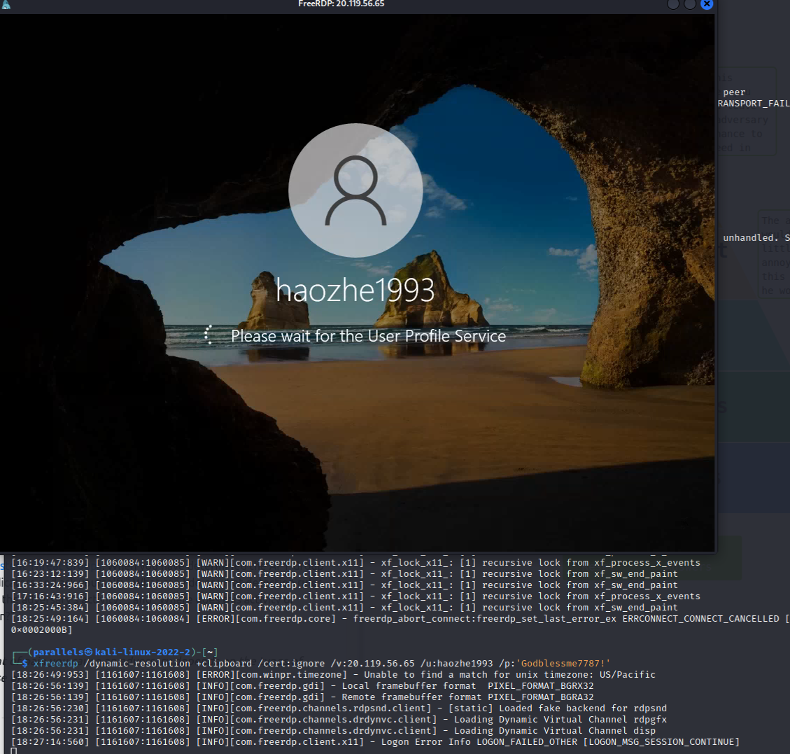

1. After loginto the server manager, go to tools->computer management->disk management -> MBR (Master Boot Record)

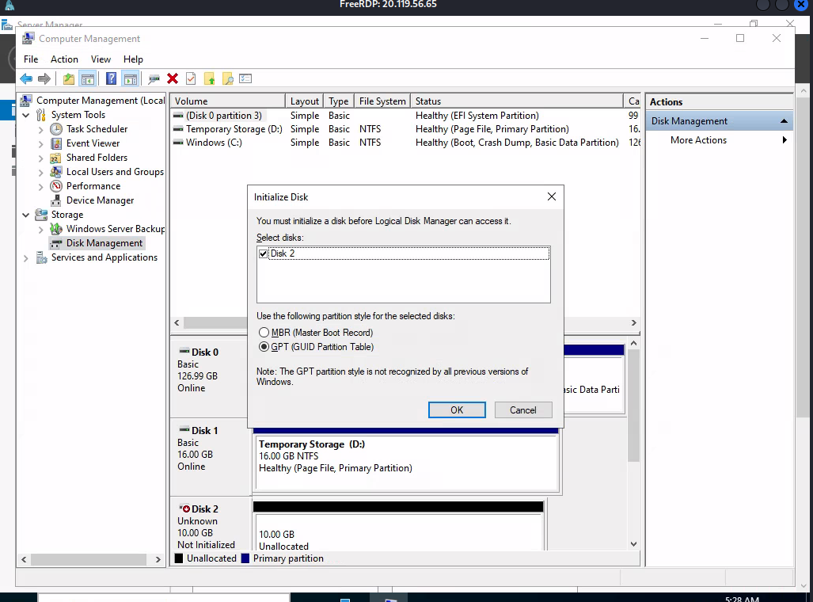

Format the Disk 2

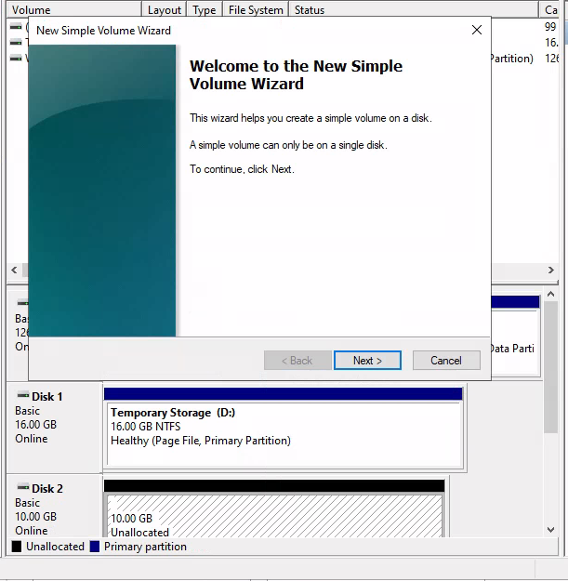

Create a simple volume, click next all the way to the end and finish

1. Install AD
   1. Back to Server Manager Dashboard, go to manage->Add roles and Features->role-based installation-> choose active directory domain services->check restart the server option-> install
      1. This is not ad installation, this is a preparing ad installation by adding features, once the installation is done and all features are set up, then promote this to a DC(domain controller).
      2. After all features are deployed, click ‘promote this server to a domain controller’ in the presenting box.

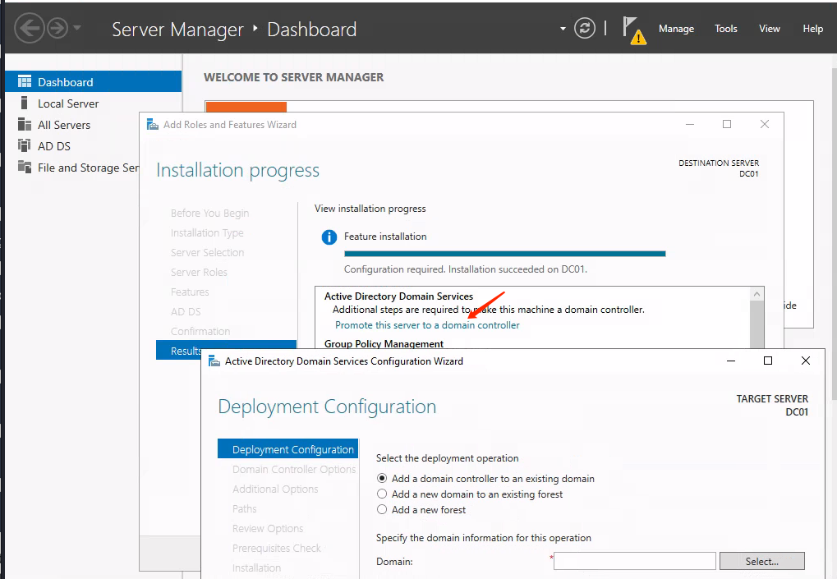

* + 1. Add a new forest, and create a password(will be used if uninstalling ad later)

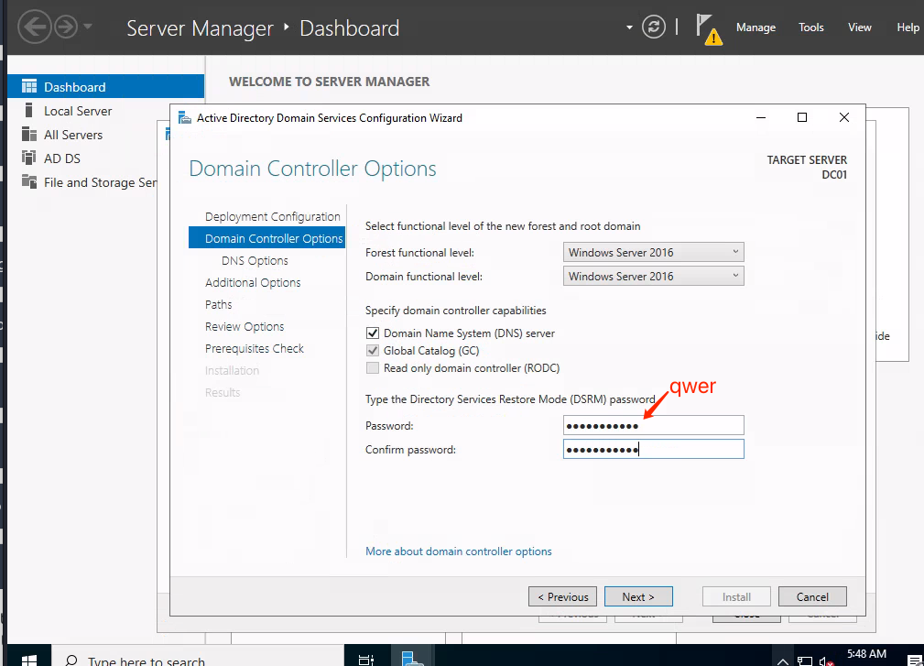

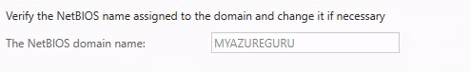

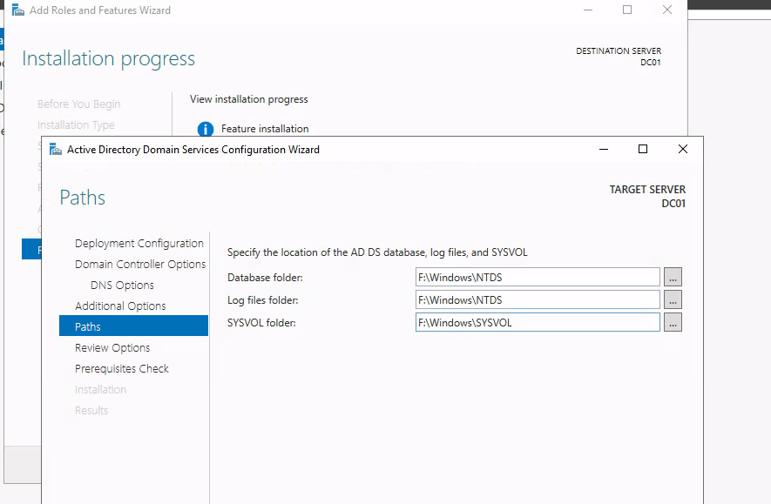

Change to F disk corresponding to previous configured disk in the disk management step above.

1. Creating a second Domain controller DC02

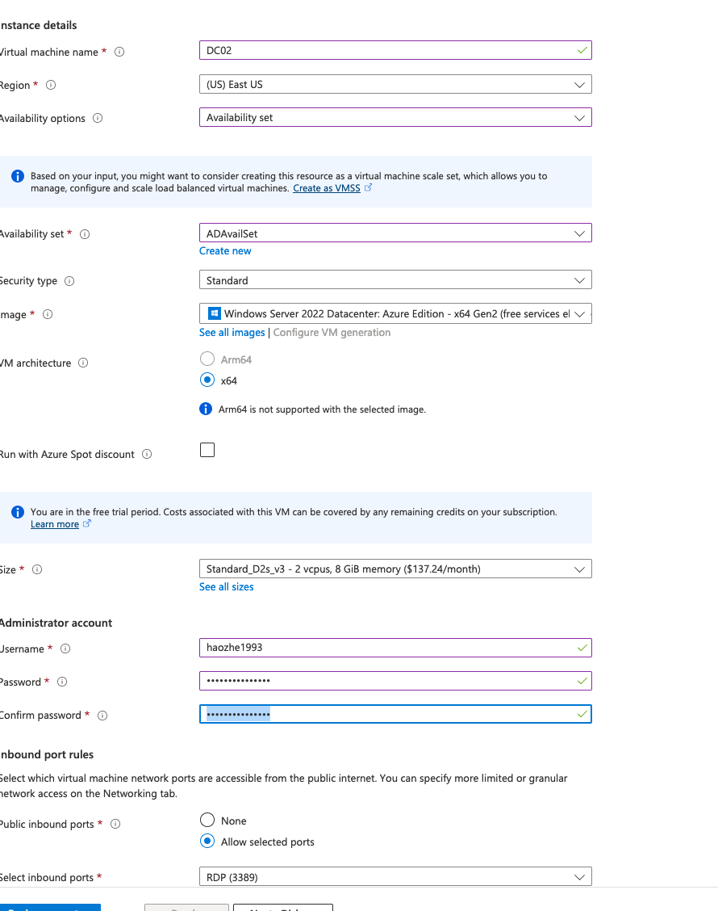

1. Go to DC01, copy the private ip: 10.1.1.4, go to networking->network interface-> ip configuration on the left pane, select ip adaptor and assign it to a static ip
2. Go to virtual networks->DNS servers on the left pane->using custom

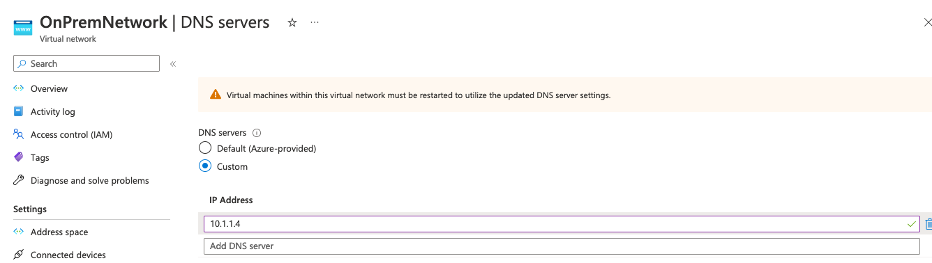

We are using active directory for our dns instead of azure

1. VM DC01-> tools-> AC users and computers

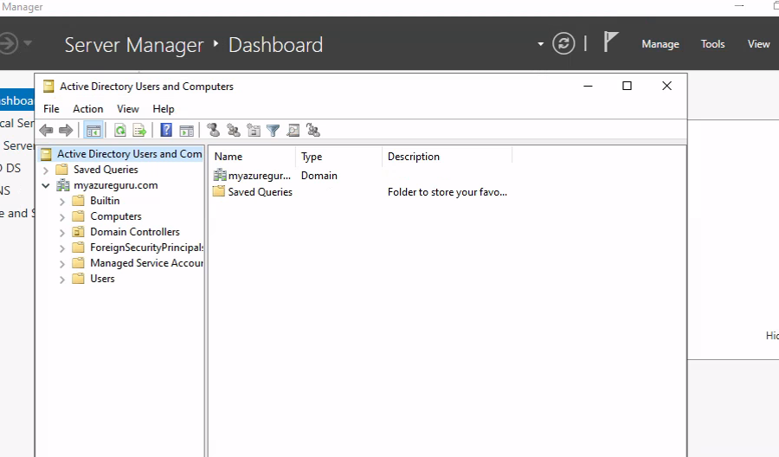

1. Restart DC02, makes sure it gets dns from DC01 instead of Azure(I assume DC02 is directly linked to DC01 since they are in the same available set)

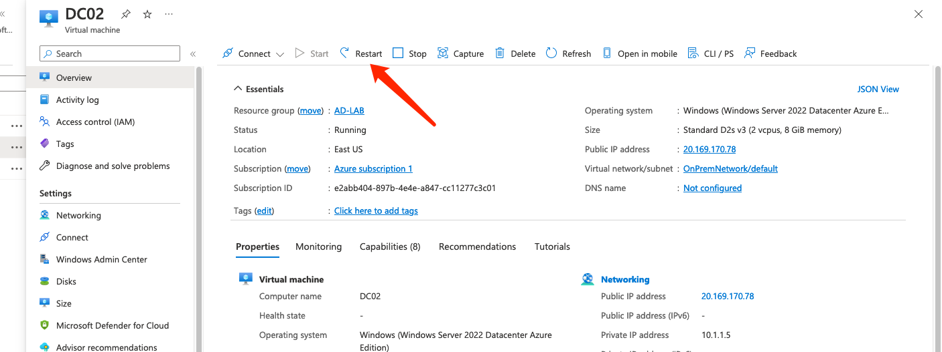

1. VM DC02 -> computer management, forma the disk, click next all the way and complete
2. VM DC02 -> Manage-> Add Roles and Features
   1. Here we are going to install active directory on DC02
   2. After installing all features, promote this server to Domain controller
   3. Adding a new domain to an existing forest (Important), different from when promoting server 1 to DC
   4. Change credentials

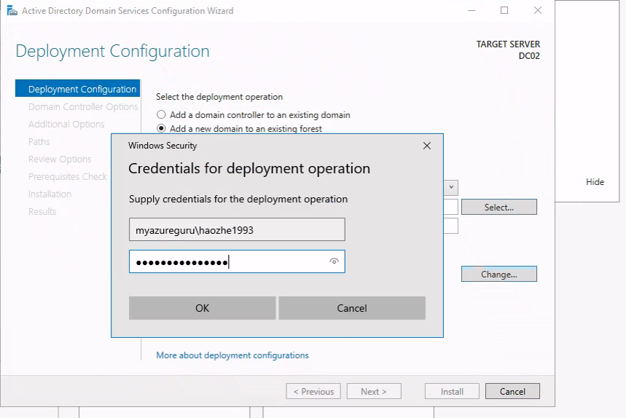

Didn’t work in my case, needs to add server to the domain(myazureguru.com) first then promote it to the domain controller.

Instruction:

(<https://rdr-it.com/en/howto/windows-server-join-an-active-directory-domain/>)

* 1. Go to next and type in the DC password

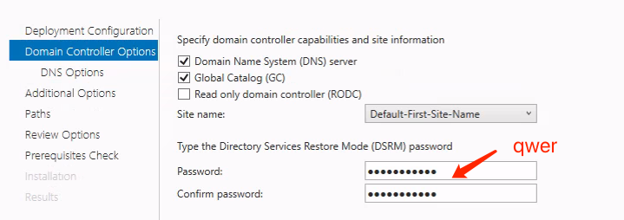

* 1. At additional options, change replicate from to DC01.myazureguru.com

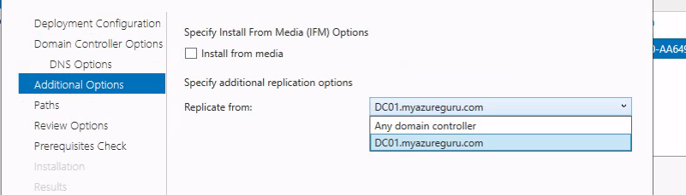

* 1. Change paths to F disk, if drive crashed, the ad is not lost because not saved in C

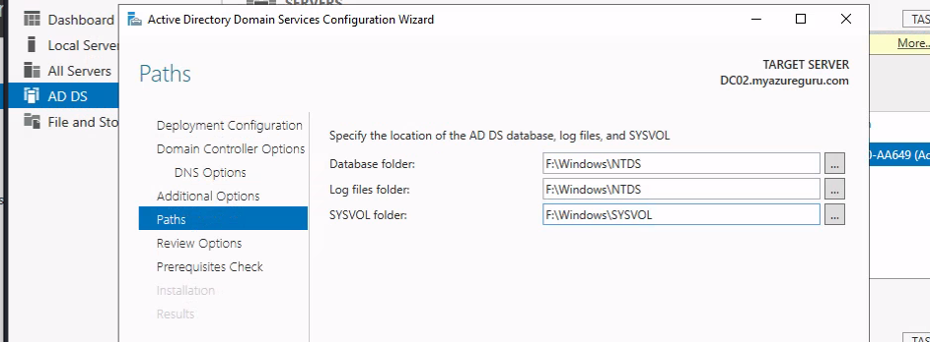

* 1. Reboot and reconnect to the rdp

1. VM DC02-> tools-> AD users and computers->Domain Controllers, both DC01 and DC02 are added.

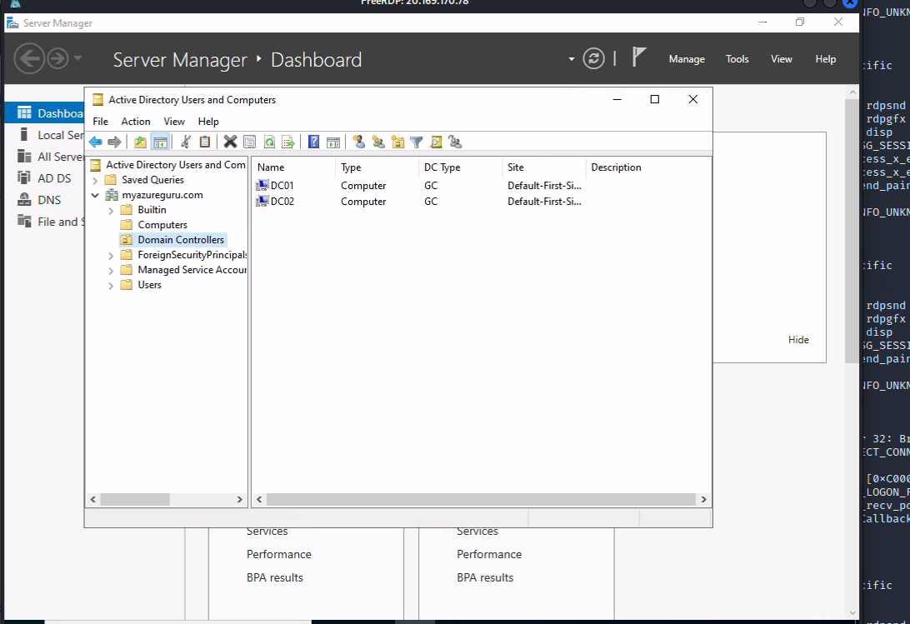

1. Go to Azure->VM DC02->copy private ip: 10.1.1.5 -> virtual networks -> onPremNetwork->DNS servers on the left pane->add copied ip to DNS servers

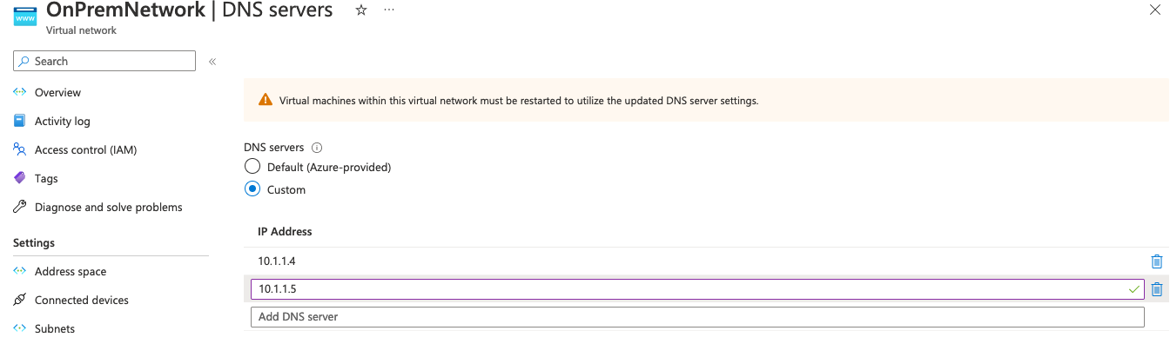

Both servers are up and running

1. Go to Azure Virtual Machines DC02->Networking->network interface-> IP configuration->click ipconfig1->change ipconfig1 to static 10.1.1.5

If the domain controllers ip addresses change, there will be issues connecting to them

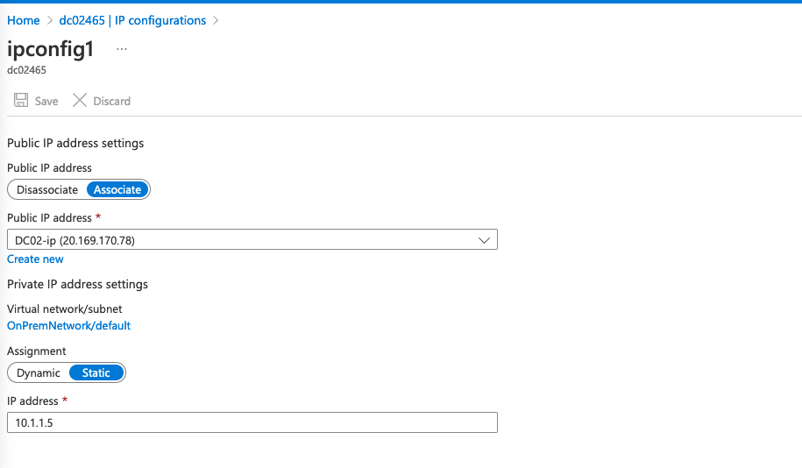

1. RDP VM DC 01->server manager->Tools->AD sites and services->change site name to OnPrem

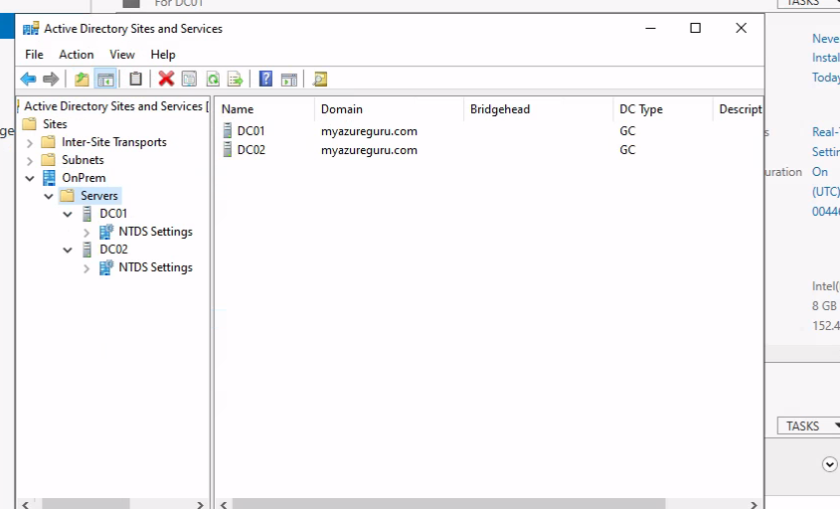

1. Azure->Virtual networks->OnPremNetwork->subnets-> RDP DC01 -> add new Subnets to Active Directory Sites and Services

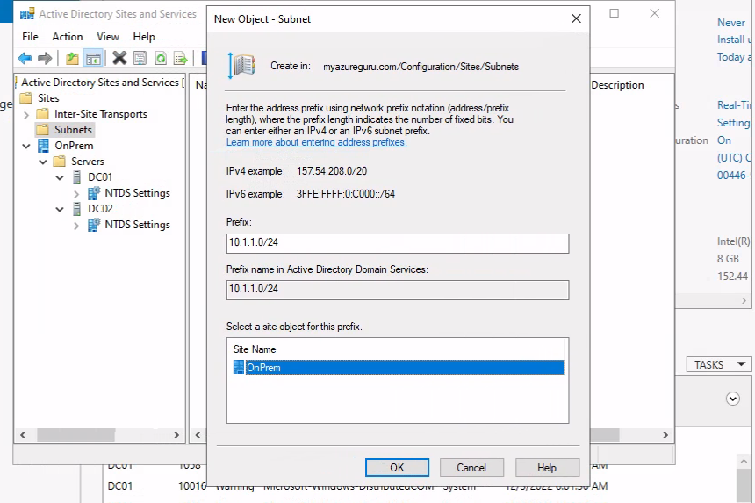

1. Tools-> AD users and computers -> right click on top level file and choose change domain controller

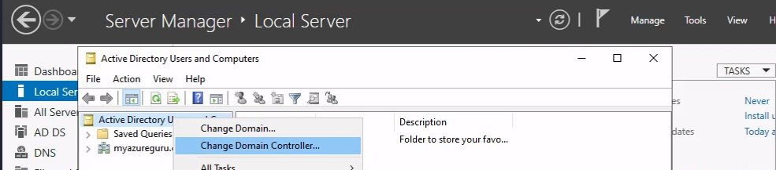

->change to the DC would like to use

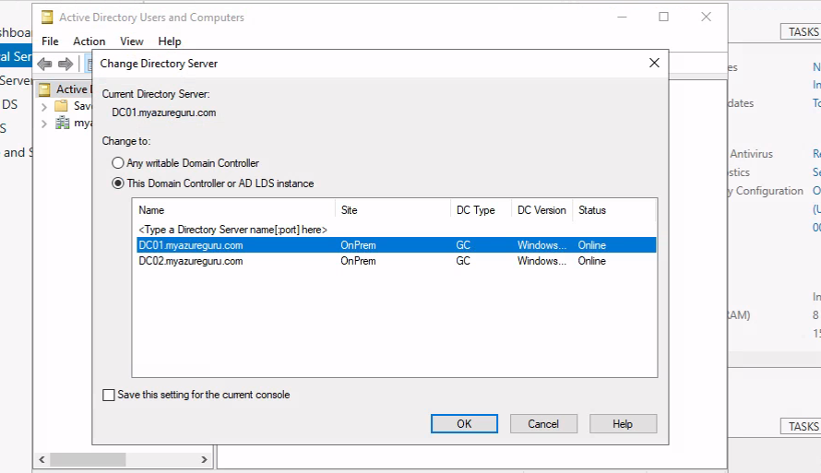

->create new users in Users file

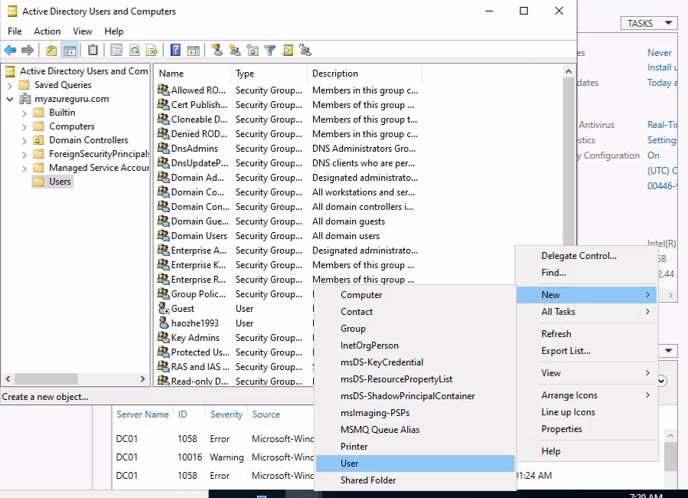

->create new user with username:testuser1, passwd: 1234__zhz

1. RDP DC02->tools->AD users and computers

We can see that testuser1 gets replicates to DC02 domain controller successfully

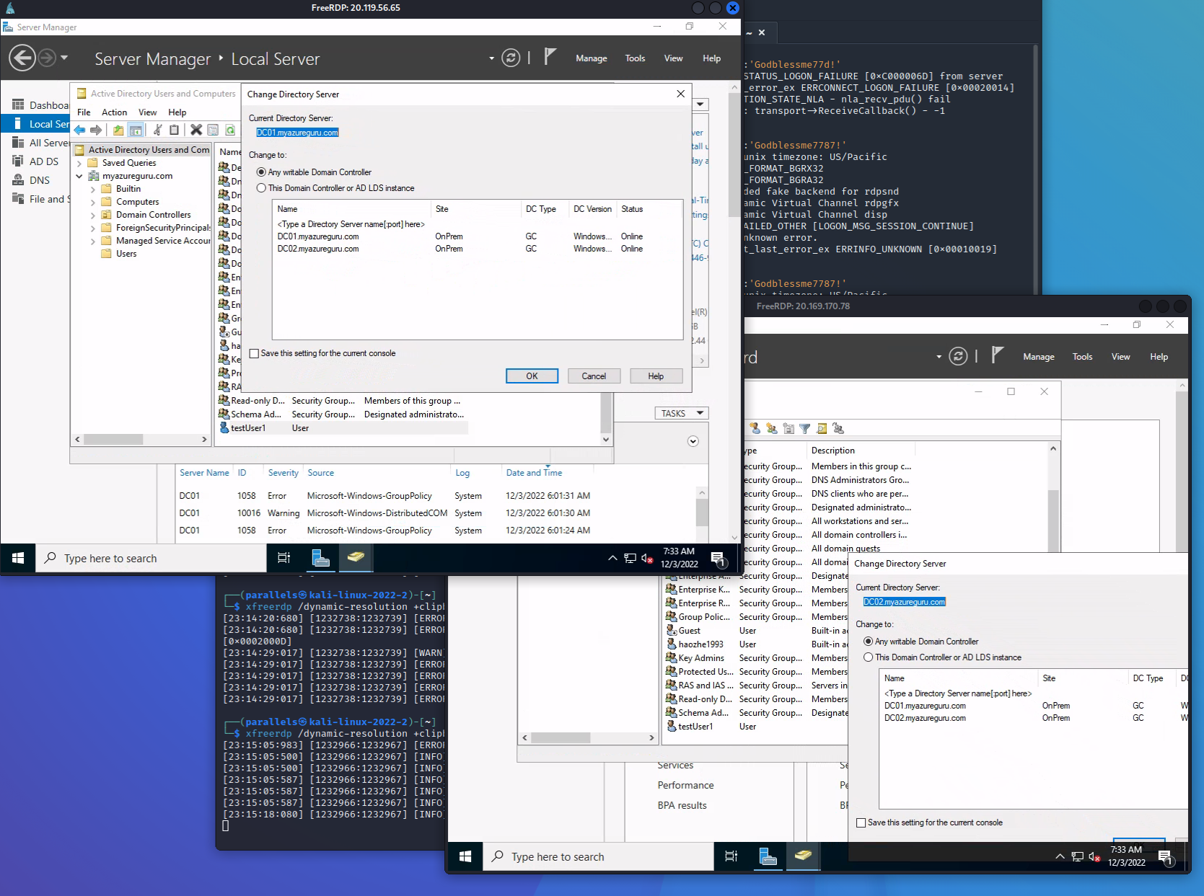

Great, we successfully deployed a dual domain controller in Azure, we used domain controller active directory and DNS (not azure dns)

1. Adding admin to our DC

Tools->AD users and computers

Create a new group called admins

Create a customized new user as admin **a-jzhang**

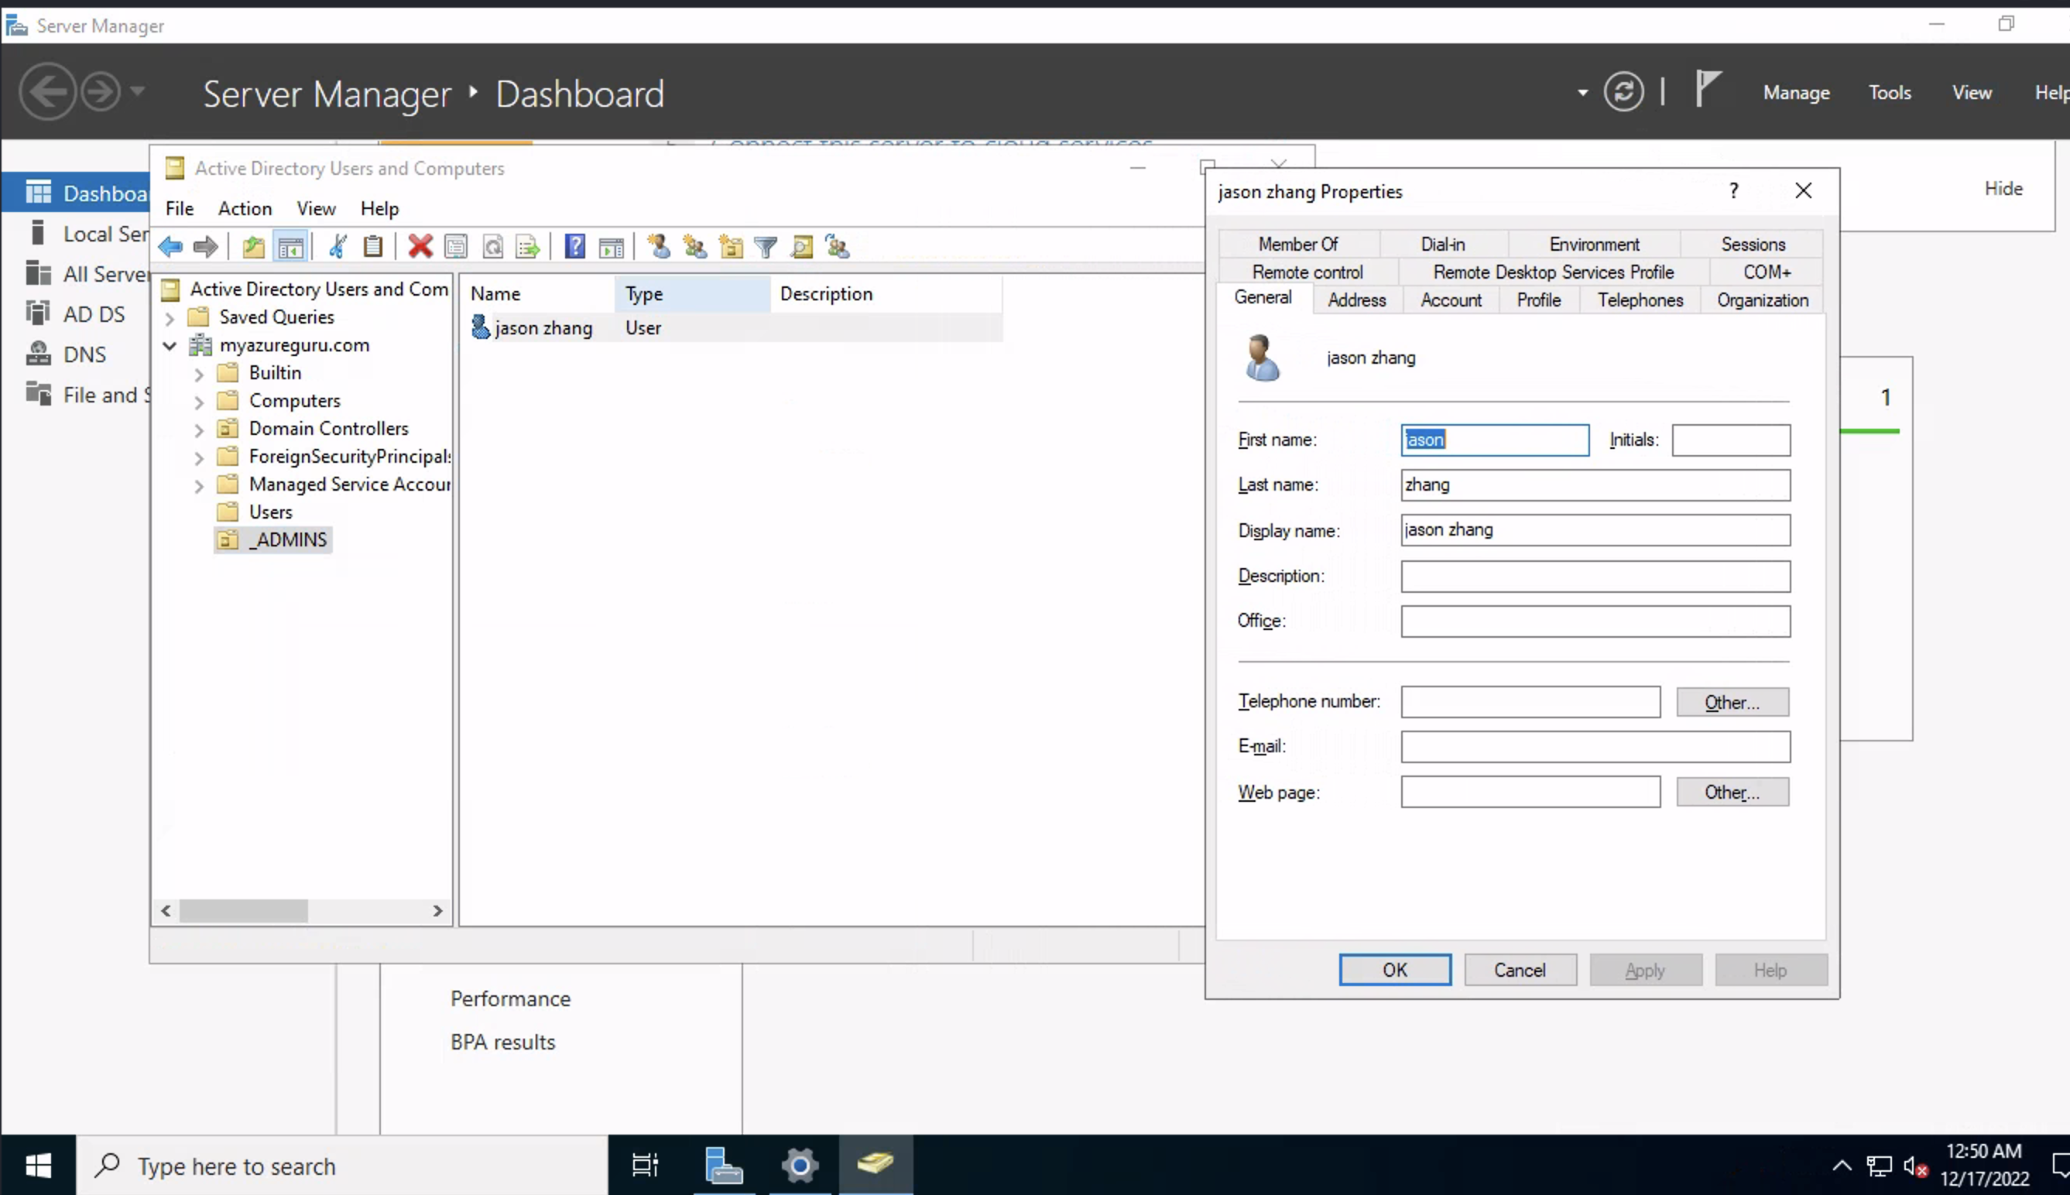

Right click on properties

Go to member of

Add domain admin

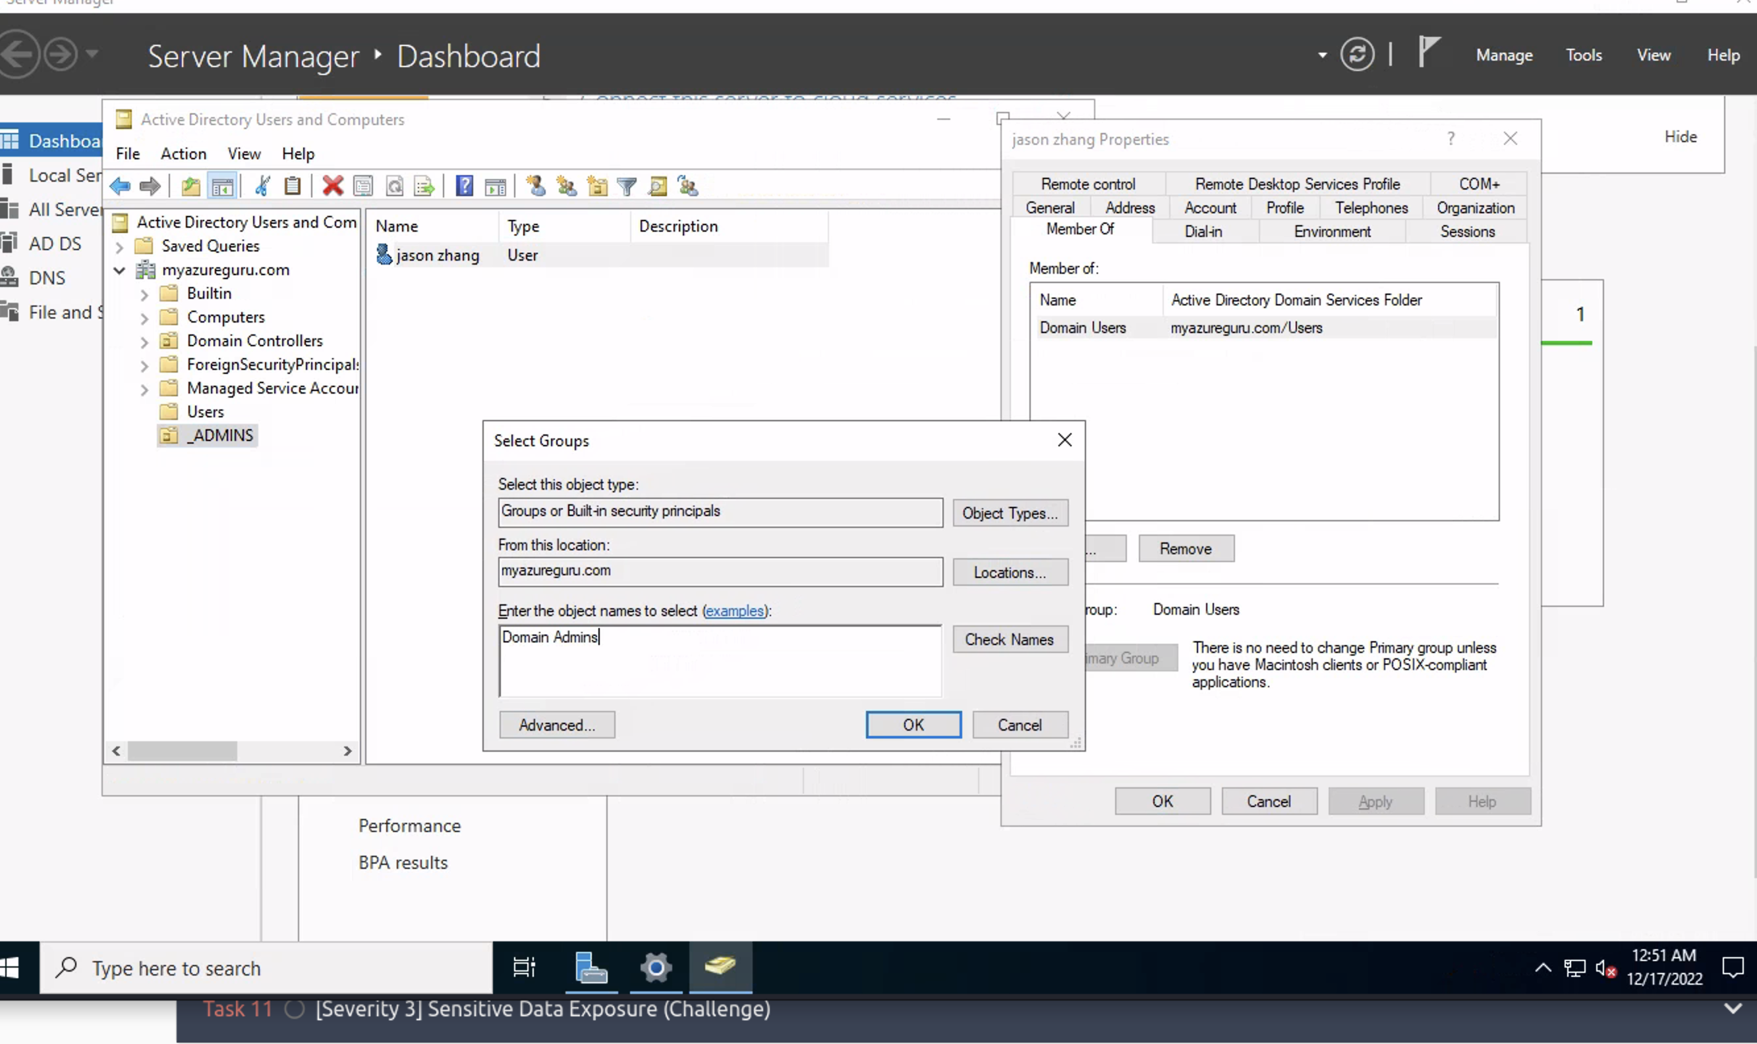

Log back on to the machine using admin account

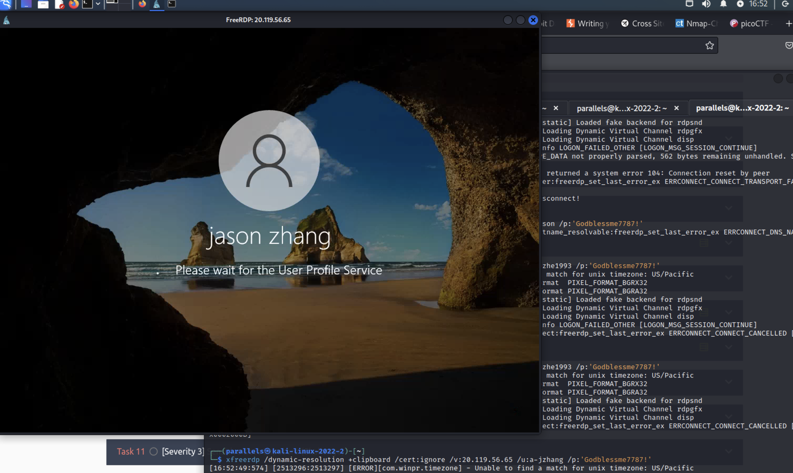

1. Change adapter options
2. Add RAS/NAT

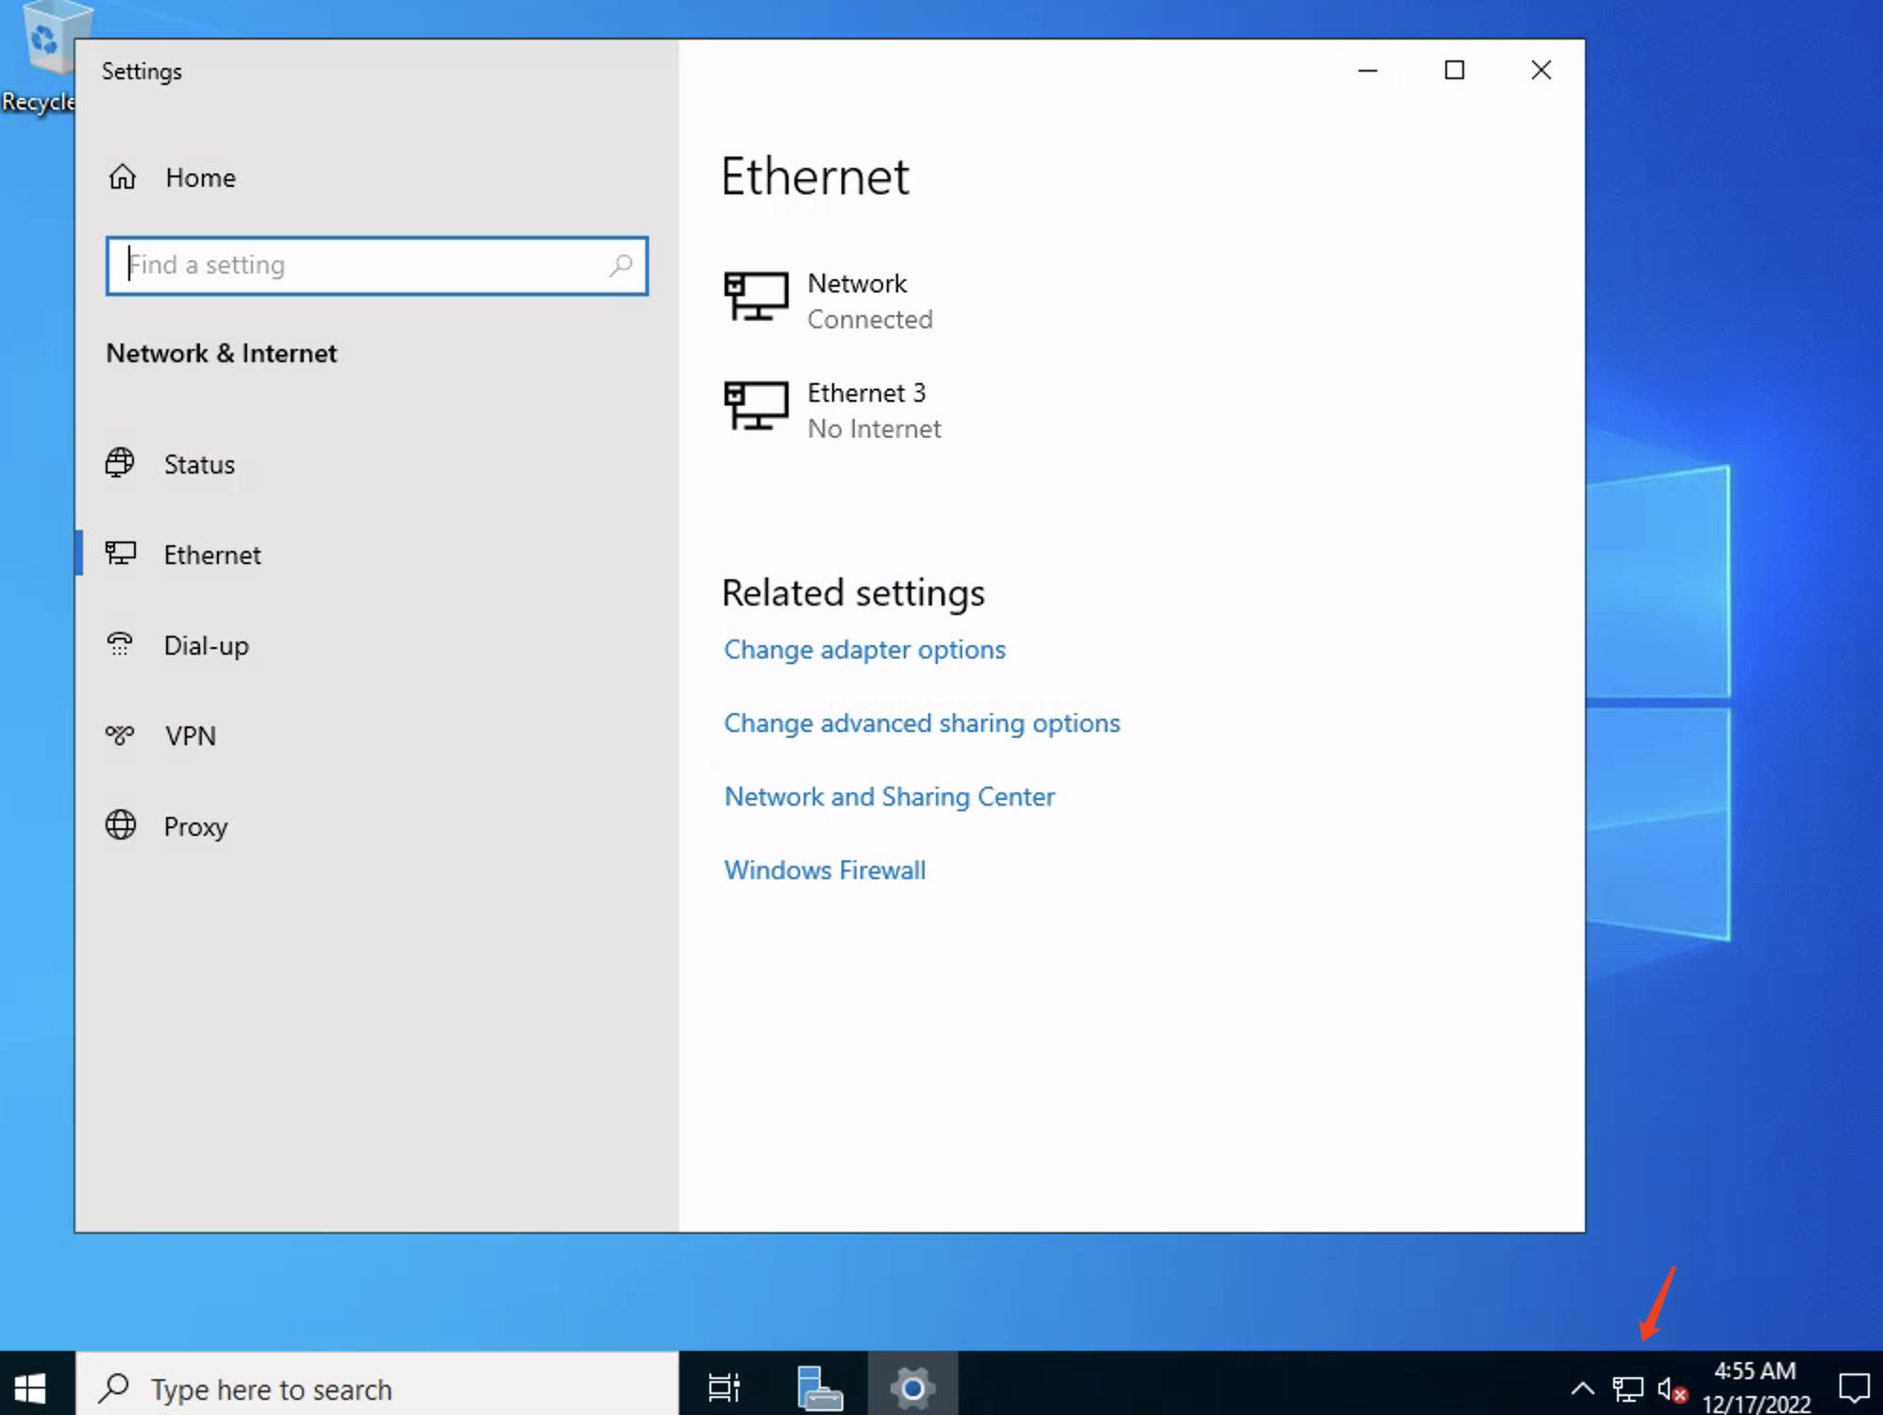

Allow client enter this private virtual network be still be able to access the internet through the domain controller

Go to add roles and features -> add remote access

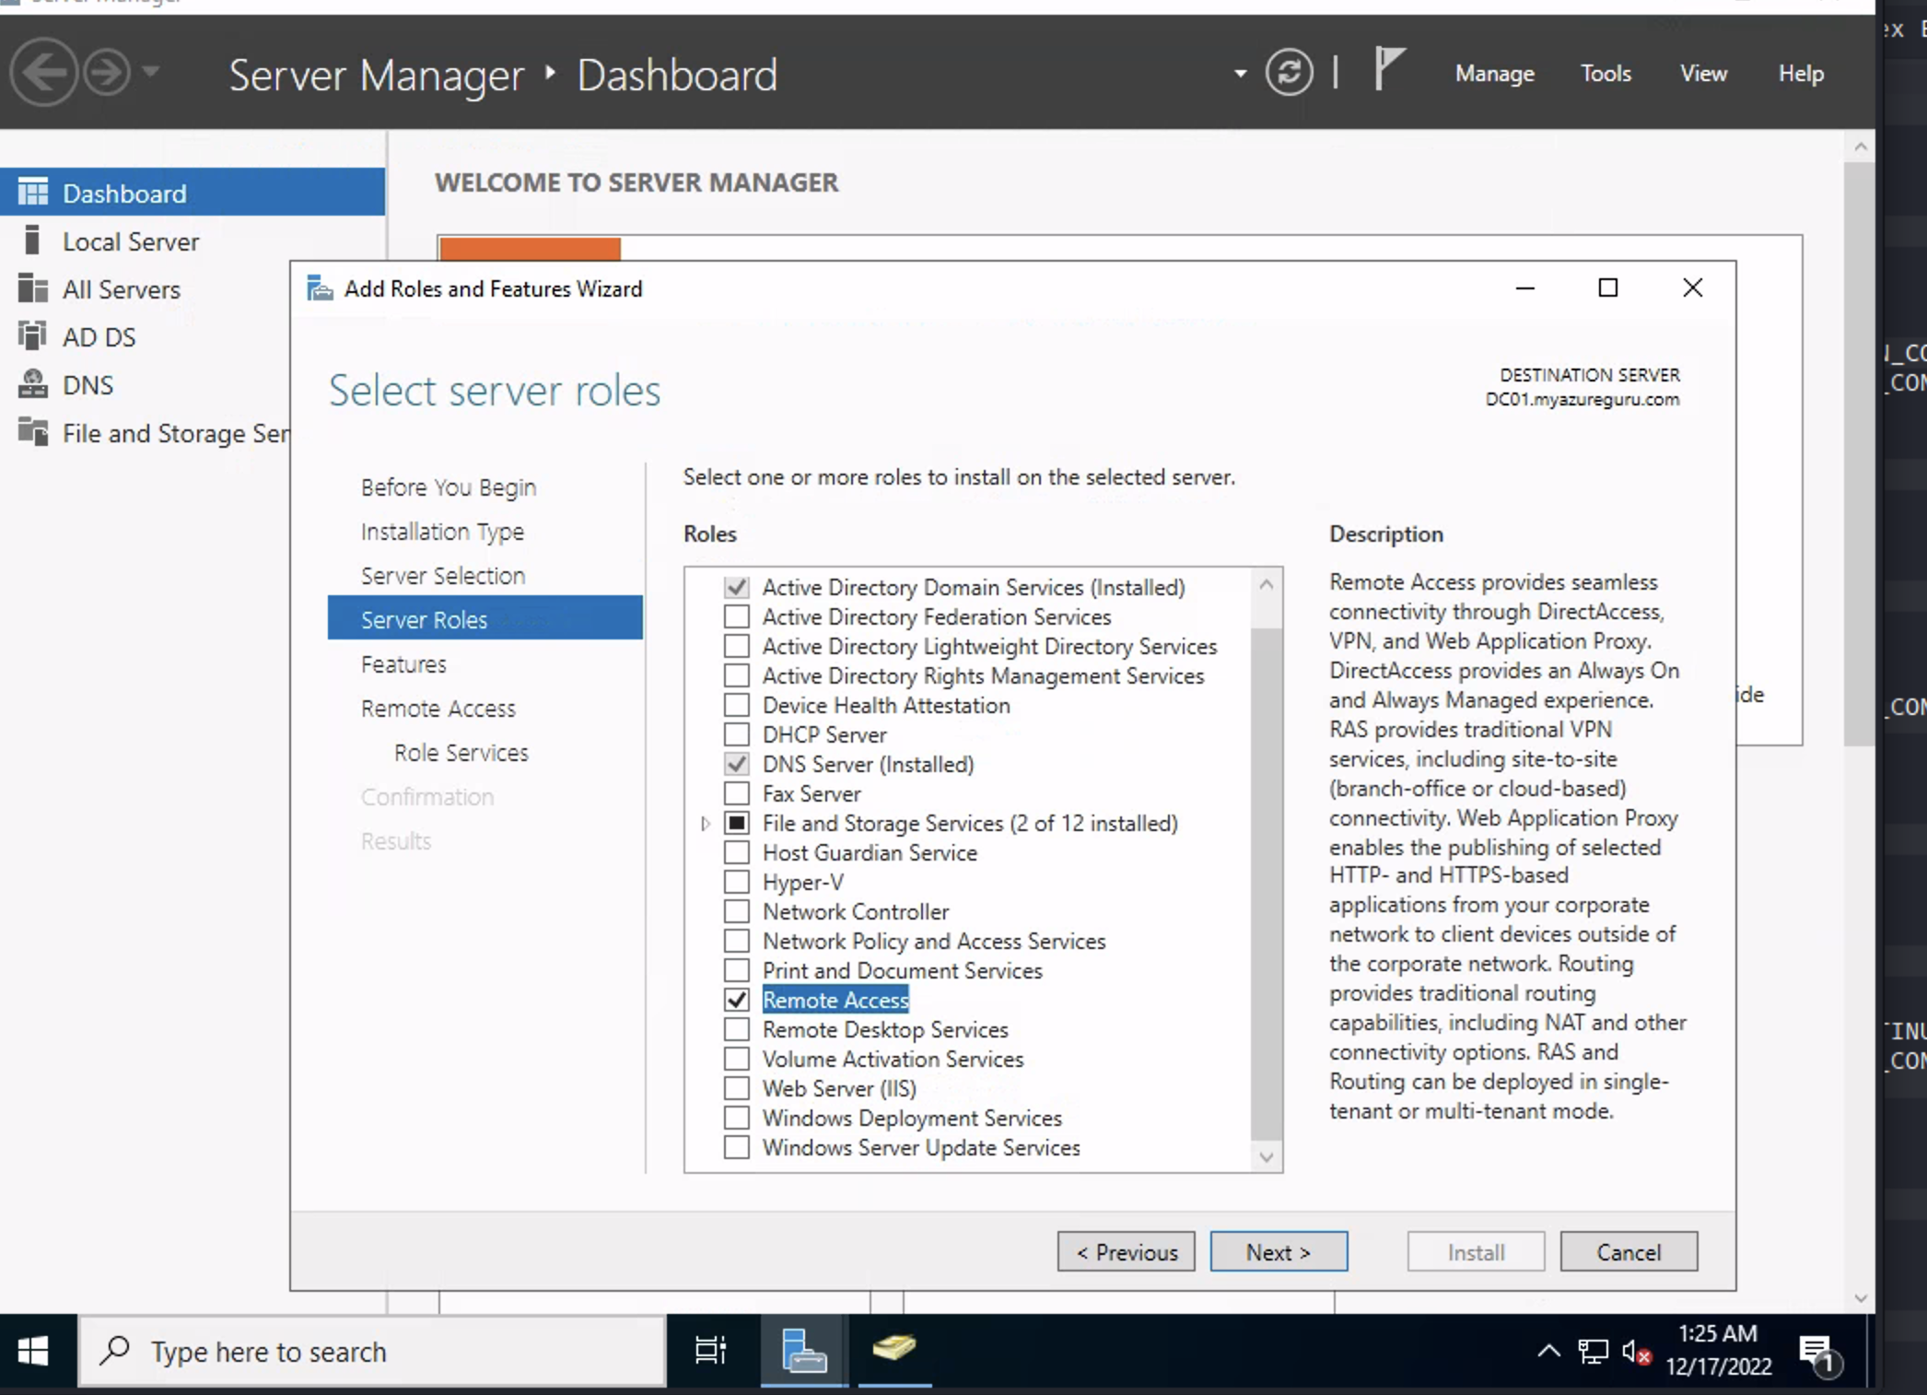

Add directAccess and VPN(RAS)

Add Routing

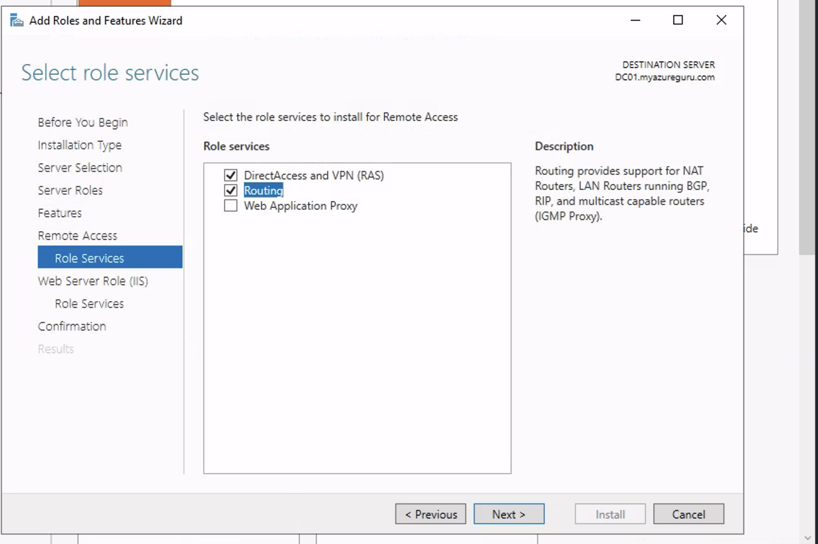

1. Toots-> Routing and remote access->

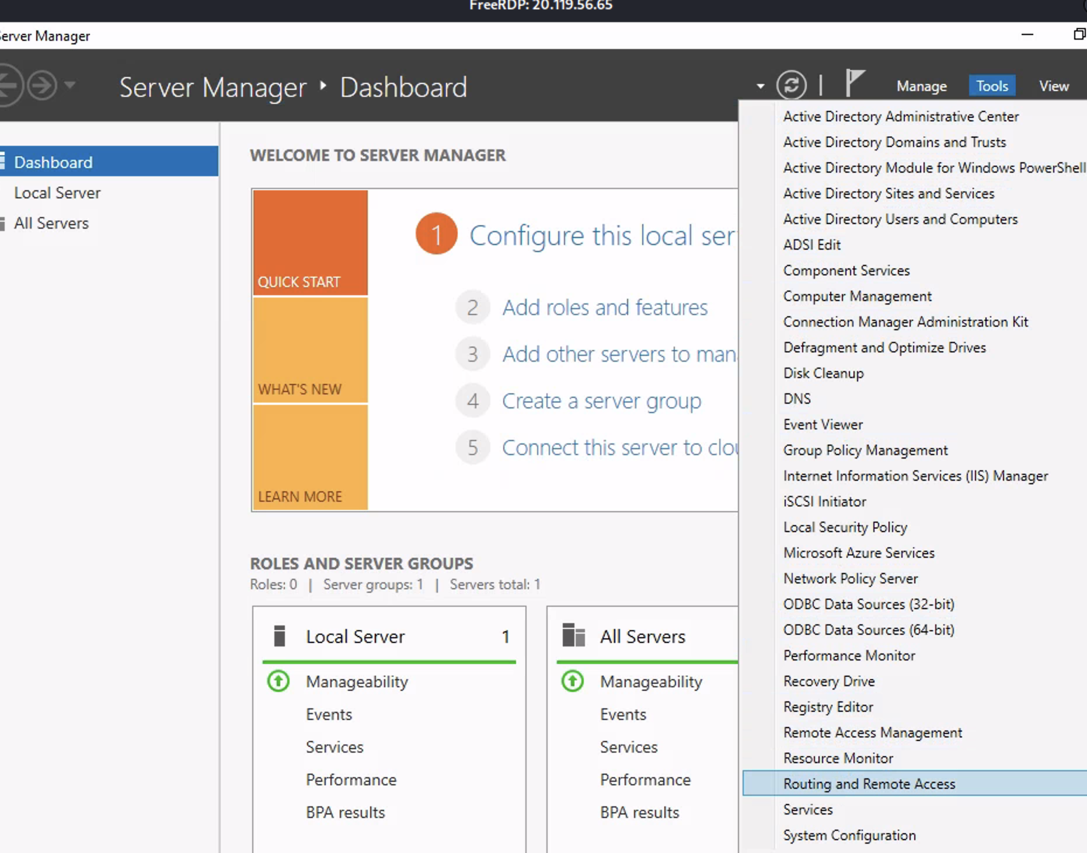

Configure and enable

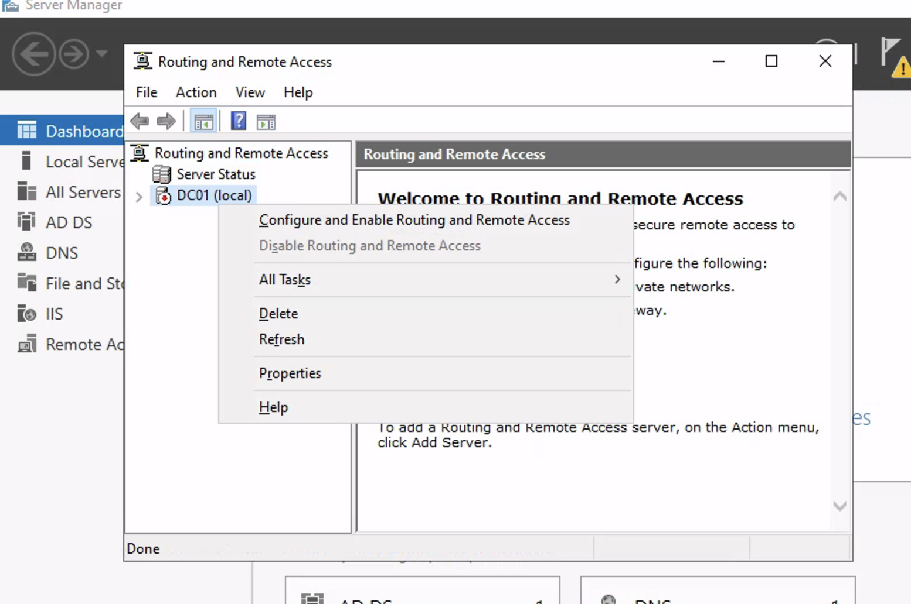

Install NAT

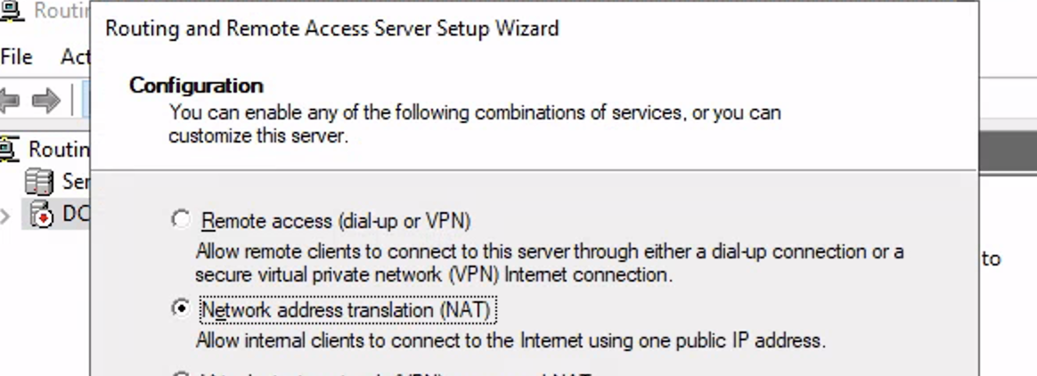

1. Download create name poweshell
2. Set-ExecutionPolicy Unrestricted
   1. Cd C:/users/a-jzhang/downloads\AD_PS-master\AD_PS-master
3. Create a client vm in parallel

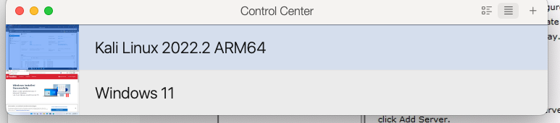

Rdp to client1 vm and add join it to the domain of myaureguru.com

